Introduction to Genetics – Similarities and Differences between Family Members

1a. How would you describe the similarities and differences in appearance of parents and their offspring? Do family members tend to have more similar characteristics than unrelated individuals?

1b. Propose a hypothesis to explain how genes contribute to both the similarities and differences in family members’ characteristics. Try to include explanations of how genes are inherited and how genes influence a person’s characteristics.

How do genes influence our characteristics?
A gene is a segment of a DNA molecule that gives the instructions for making a protein. Different versions of the same gene are called alleles. Different alleles give the instructions for making different versions of a protein, and the different versions of a protein can result in different characteristics. This chart shows an example.

Genotype | → | Proteins | → | Characteristics
AA | → | Normal enzyme that makes melanin, the pigment that gives color to skin and hair | → | Normal skin and hair color | 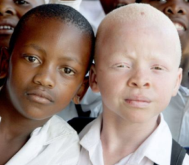
Aa | → | Normal enzyme that makes melanin and defective enzyme that does not make melanin | → | Normal skin and hair color
aa | → | Defective enzyme that cannot make melanin | → | Very pale skin and hair (albino)

Notice that each genotype has two letters. These letters represent the alleles for the two copies of the gene that a person has in each cell.
- A person is homozygous for a gene if both alleles for that gene are the same.
- A person is heterozygous for a gene if the two alleles are different.

2. Use the information in the above chart to explain why a person with the aa genotype has very pale skin and hair.

3a. This chart illustrates how a dominant allele (A) can determine the characteristics of a heterozygous person. Explain why a person who is heterozygous (Aa) has normal skin and hair color.

3b. Explain why the recessive allele (a) does not influence the characteristics of a heterozygous person.

3c. A heterozygous person has the same characteristics as a person who is homozygous for the
_______________________ allele.
(dominant/recessive)

How does a child inherit genes from his or her mother and father?

4. Each gene is a small part of a long DNA molecule. Each DNA molecule, together with associated proteins, is a chromosome. This flowchart summarizes how genes in chromosomes are passed from parents to child by the processes of meiosis, fertilization, and repeated mitosis. Fill in each blank to complete the flowchart.
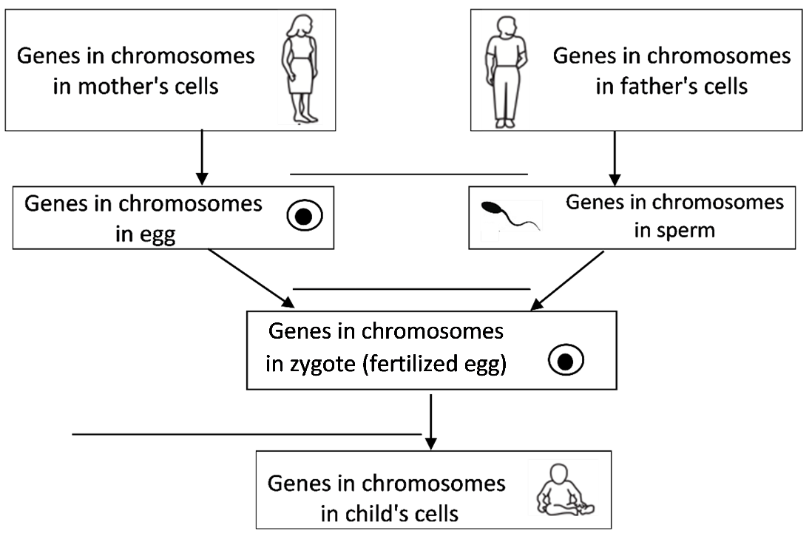

5. Explain how each cell in a child’s body gets one copy of each gene from each parent.

How Inheritance of Genes can Result in Family Similarities and Differences

To begin, you will analyze these questions:
If both parents are heterozygous (Aa), what different combinations of A and/or a alleles will their children have? Will the children have the same characteristics as their parents?

In this figure, the top circle shows a pair of chromosomes in a cell in a heterozygous Aa father. Each chromosome has two sister chromatids.  6a. Complete the figure to show how the chromosomes and sister chromatids separate during meiosis.  6b. Label the row of circles that represent sperm.  6c. What is the genetic makeup of the different types of sperm that an Aa father can produce? _A_ or ____  6d. What is the genetic makeup of the different types of eggs that an Aa mother can produce? ____ or ____ | 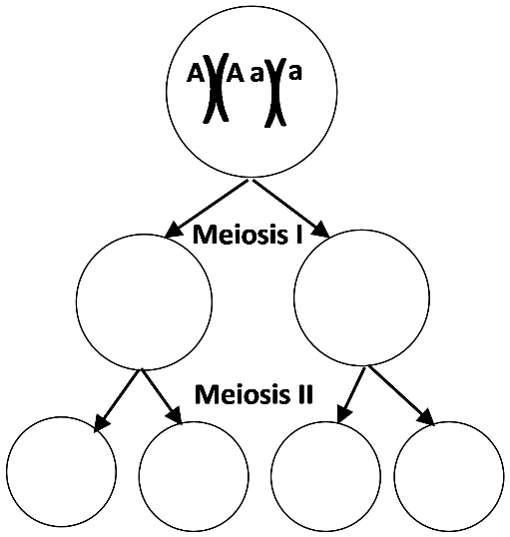

7a. This figure shows fertilization of each different type of egg by each different type of sperm. To show the outcomes of fertilization, label the allele (A or a) for each chromosome in each zygote.  7b. Circle the combination of egg and sperm that will produce an AA zygote.  7c. Although neither parent is albino, they could have an albino child. Put a square around the zygote that would develop into an albino child. | 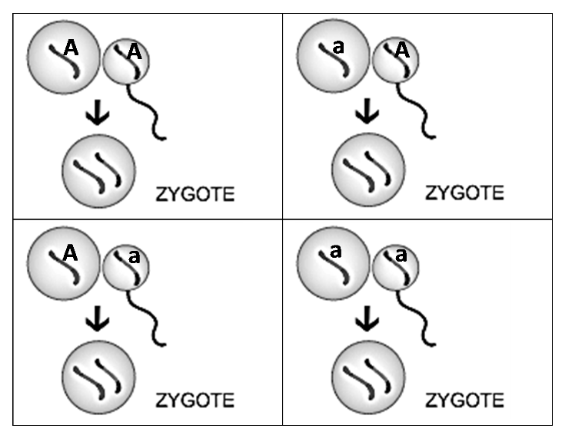

This chart combines the results of meiosis and fertilization for an Aa mother and an Aa father. It shows the genetic makeup of the different zygotes that meiosis and fertilization could produce.  8a. Label the arrows that represent meiosis.  8b. Circle the part of this chart that shows how meiosis and fertilization could produce an AA zygote. | 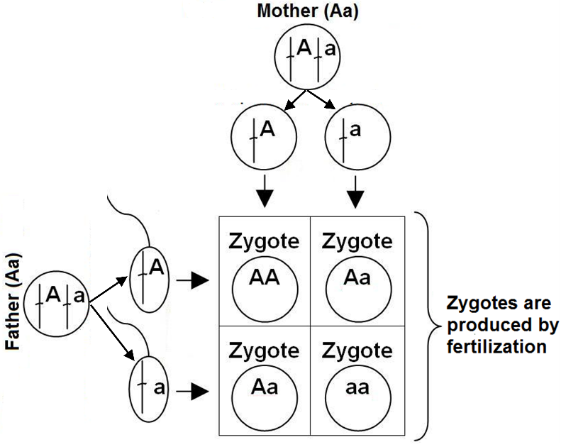

Biologists use a similar chart to analyze inheritance. However, biologists omit much of the detail and use a simplified version called a Punnett Square. | A  a | A | a
 |  | AA | Aa
 |  | Aa | aa

9a. The pair of letters in each rectangle in the Punnett square is interpreted as the genotype of a child that these heterozygous Aa parents could produce. This contrasts with the above chart where the same pairs of letters are interpreted as the genotypes of zygotes. Explain why the genotype would be the same for a child and the zygote that the child developed from.

9b. Circle the part of the Punnett square that shows that these parents could have a child with the AA genotype.

10. Explain how two heterozygous Aa parents could have a child who has a different characteristic that neither parent has.

11a. To further investigate how genes contribute to the similarities between parents and their children, draw a Punnett square for two albino parents.

11b. Explain why two albino parents will have only albino children.

12a. The genotype of a parent who is not albino is ______ or ______. Complete a Punnett square for each possible combination of these parental genotypes.

12b. For these Punnett squares, both parents are not albino. Circle the genotypes of each possible child who would have the same characteristic as both parents.

13. Use what you have learned to explain how genes contribute to the generally similar appearance of family members.

14a. Based on the number of albino children you have ever seen, what is the genetic makeup of most parents? AA ___ Aa ___ aa ___

14b. Explain your reasoning.

15a. In this pedigree, the solid black squares or circles represent individuals who were albino; everyone else is not albino. Give the genotype of each albino person and each of the Parents. | 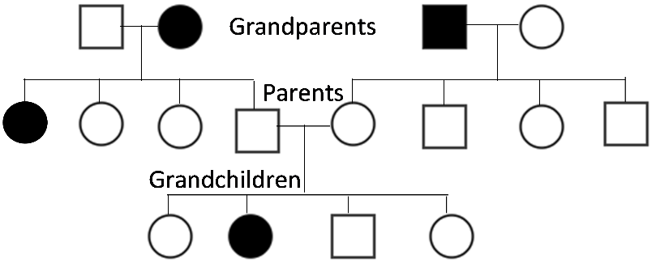
15b. Give a genetic explanation for why the second grandchild does not look like either of her parents, but instead looks like two of her grandparents and one of her aunts.

16a. Can these two alleles of this gene be the cause of all the different skin colors that different people have? yes ___ no ___

16b. Explain your reasoning.

Family Similarities and Differences for Characteristics that are Influenced by Multiple Genes

The many different skin colors that people inherit are caused by multiple alleles of multiple genes. Adult height is another characteristic that is highly variable and influenced by multiple alleles of multiple genes.  To begin our analysis of the genetics of height, we will consider one of the genes that affects the activity of cells in the growth plates of leg bones. Growth plate cells make new bone, which increases the length of leg bones, which increases height.  The G gene provides the instructions for making the G protein.  ↓  The G protein can stimulate the secretion of growth hormone.  ↓  Growth hormone stimulates the cells in the growth plates to divide and produce more cells that increase the growth of leg bones.  17. How could different versions of the G gene influence a person’s height? | 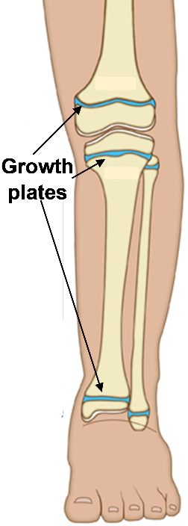

This table shows the effects of two alleles of the G gene; these effects are added to the effects of the multiple other genes that influence height. Notice that a heterozygous person has a
height that is intermediate between the heights of either type of homozygous person. This is called incomplete dominance. | Genotype | Effect on Adult Height
 | G⁰G⁰ | 0 (average height)
 | G⁰G¹ | - 1 cm (shorter than average)
 | G¹G¹ | - 2 cm (shorter than average)

18a. Complete each Punnett square.

2 G⁰G⁰ parents |  |  |  | 2 G⁰G¹ parents |  |  |  | 2 G¹G¹ parents

18b. In question 18a, label the parents who will tend to be the shortest.

18c. Explain why the offspring of shorter parents tend to have shorter adult height.

18d. Explain how two adult siblings who have the same biological mother and father can have different heights.

There are dozens of genes like G that affect height. Many alleles of these genes have small effects on adult height. Environmental factors such as poor nutrition during childhood can result in slower growth and shorter adult height.

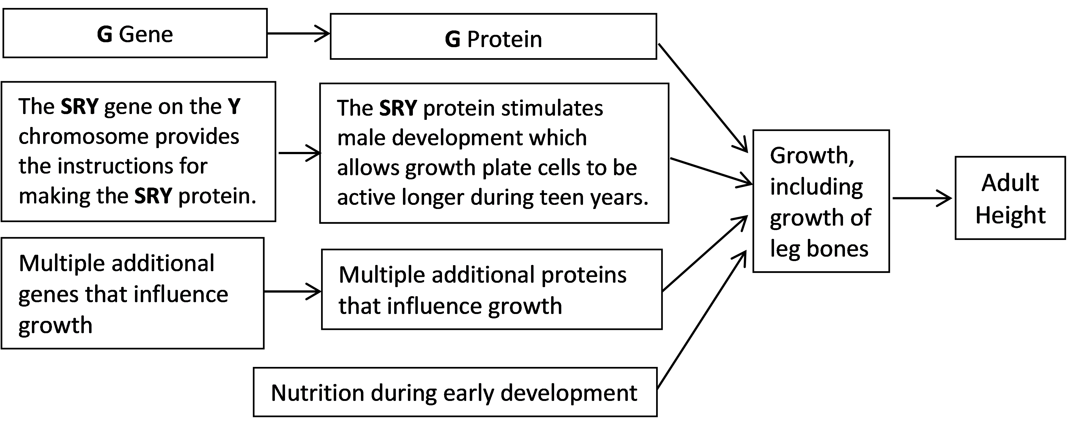

19. Some characteristics (e.g., blood types) have only a few possible values. Explain how genes and environmental factors result in many different adult heights.

20a. The flowchart below summarizes the genetic reasons for similarities and differences in adult height of family members. What biological processes transmit genes from parents to child (represented by the thin black arrows)?

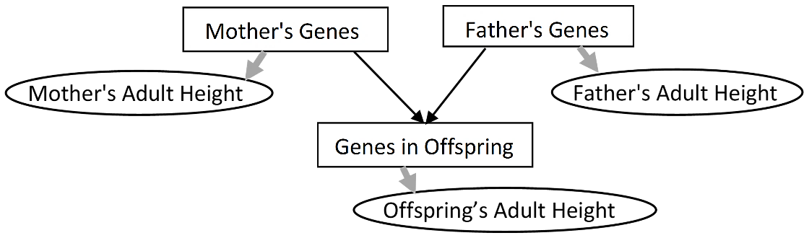

20b. Explain how genes influence a person’s characteristics (represented by the thicker gray arrows). A complete answer will include the words alleles and protein.

20c. Summarize how genes contribute to the similarities and differences in adult height for family members. A complete answer will include the processes shown in the flowchart in 20a.

By Drs. Ingrid Waldron and Scott Poethig, Dept Biology, Univ Pennsylvania, © 2021. This Student Handout (including a Google Docs version) and Teacher Notes (with background biology and instructional suggestions) are available at https://serendipstudio.org/exchange/bioactivities/geneticsFR.

